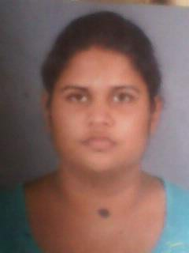

R.S.HASHANI ERANDIKA.

NO: 7/8, MIHIKATAWATTA, KITULAWA, KALUTARA SOUTH.

<Tel:residence-034-2040098>

Mobile-077-9593830

**Vision**

To become reputed and unique professional available in any relevant field to my qualifications.

**Mission**

Gaining knowledge, attitude and skills in order to facility the smooth running towards the vision.

**Other qualifications.**

* Followed course in spoken English course at “Oxbridge college”. Have “B” pass.
* Followed diploma in “IT” and “SOFTWARE” at “Langway institute”, have “B” pass
* Following a “HR” course at the “LAVTC”.
* Following a “GRHAPIC DESIGN “diploma at the “BICT”.

**Education qualification.**

**G.C.E. (advanced level) examination 2013(art stream)**

**Subject grade**

* Sinhala A
* Indian history B
* Buddhist civilization C
* General English S

**G.C.E (ordinary level) examination 2010**

**Subject grade**

* Sinhala C
* English C
* Buddhism C
* History C
* Art C
* Health C
* Science S
* Mathematics W
* Business studies W

**Extracurricular level activities.**

* 2007-2008 was an active member of the Buddhist association.
* 2007 played for the school net ball.
* 2008-2009 was a team leader of the environment society
* 2009-2010 was a perfect of the Sunday school
* 2009 was attending the machinery exhibition.

**School level achievements.**

* 2009 won the price for the best drama creation
* I have participated for the drill display
* 2009 was won the price and certificate from the “samastha lanka” competition

**Specific qualification**

* Have skill in drawing pictures, writing songs.
* Good at English
* Good at computer ms word, excel, power point, access, java, html, sap, adobe PageMaker, flash, PHOTOSHOP

**Reference**

**MR.ARIYAPALA**

**THE JUSTICE OF PEASE**

**ALWISWATTA,**

**KALUTARA SOUTH.**

I certify that the about furnished particulars are true and accurate to the best of my knowledge.

2015.03.20 HASHANI ERANDIKA.